**SWE Project documentation – Mental Health Website**

**Table of Contents**

1. **Introduction………………………………………………………1  
   1.1 Purpose……………………………………………………….1  
   1.2 Scope………………………………………………………….2**
2. **Overall Description……………………………………………3  
   2.1 Product Perspective…………………………………….4  
   2.2 Product Features…………………………………………4 2.3 User Classes and Characteristics………………….5**
3. **Requirements……………………………………………………5  
   3.1 Functional Requirements…………………………….6  
   3.2 Non-Functional Requirements………………………7**
4. **Tools and Technologies………………………………………7 4.1 Languages…………………………………………………….7 4.2 Frameworks and Libraries…………………………….7 4.3 Development Tools………………………………………8 4.4 Version Control…………………………………………….8**
5. **Diagrams………………………………………………………..9 5.1 Use case Diagram……………………………………………10 5.2 Class Diagram……………………………………………10 5.3 ERD…………………………………………………………..11**

**Introduction: -**

Mental health is an essential aspect of overall well-being, yet many individuals with non-serious mental health conditions such as ADHD, anxiety, and mild depression often struggle to find a safe space to share their experiences and seek support. While traditional social media platforms offer general discussions, they lack specialized communities focused on mental health, and users may not always receive guidance from qualified professionals. To address this gap, this platform aims to develop a dedicated social media platform where individuals with non-serious mental health conditions can connect, communicate, and learn in a safe and supportive environment. The platform will be exclusively for patients and licensed therapists, ensuring that all interactions are helpful, educational, and free from misinformation. It will allow patients to share their experiences related to their conditions, therapists to provide professional insights through posts and comments, and create a moderated and secure space where users can feel safe expressing themselves. This document outlines the objectives, features, and technical details required to build this platform.

**1) Purpose: -**

The purpose of this document is to provide a comprehensive overview of the Mental Health Social Media Platform, including its functional requirements, user roles, and technologies used in development. The platform aims to foster community support among individuals facing similar mental health challenges, provide a professional and reliable source of information from therapists, ensure privacy, safety, and responsible communication between users, and encourage mental health awareness through meaningful discussions.

**2) Scope: -**

This project is a web-based social media platform specifically designed for patients with non-serious mental health conditions and licensed therapists. The platform will include user authentication and roles, requiring patients and therapists to register and verify their accounts; a posting and commenting system that allows users to create posts, comment, and interact with content; therapist-patient communication, enabling therapists to guide and support patients through discussions; privacy and security measures, ensuring strict moderation, data protection, and access control mechanisms; and scalability and performance features to accommodate a growing number of users. However, the platform will not replace professional therapy or medical treatment, provide emergency mental health services, or allow private messaging between patients.

**Overall Description: -**

The Mental Health Social Media Platform is designed to provide a safe, supportive, and informative online space for individuals with non-serious mental health conditions such as ADHD, anxiety, and mild depression. Unlike general social media platforms, which often lack structured guidance and moderation, this platform will ensure that all interactions are meaningful, professional, and free from misinformation. By enabling patients to share their experiences and therapists to provide expert insights, the platform will foster a strong sense of community and encourage mental health awareness.

This section provides an overview of the platform’s perspective, features, requirements, and technologies, highlighting how it will function and meet the needs of users effectively.

**1) Product Perspective: -**

The Mental Health Social Media Platform is a specialized community-driven web application that fills the gap between standard social networks and professional mental health services. Unlike conventional platforms, where mental health discussions may lack expert validation and proper moderation, this platform is specifically designed to facilitate structured and informative interactions between patients and licensed therapists.

The platform will operate as an interactive support system, where users can post about their experiences, share coping mechanisms, and gain insights from professionals. Therapists, in turn, will engage with patients through comments, discussions, and informational posts, ensuring that users receive reliable and constructive feedback.

Since privacy is a major concern in mental health discussions, the platform will implement strict security protocols, role-based access control, and content moderation to create a safe space for users. Additionally, the system will be designed to scale, allowing it to accommodate an increasing number of users without compromising performance.

**2) Product Features: -**

The platform will incorporate essential features that enhance user engagement, security, and reliability. User authentication and role verification will ensure that only verified patients and licensed therapists can access the platform. Users will have the ability to create posts, comment on discussions, and engage with content, fostering a dynamic and supportive environment. Therapists will play a crucial role by posting professional insights, answering questions, and guiding discussions, ensuring that the shared information is accurate and beneficial.

To maintain privacy and safety, the platform will implement strict moderation policies, data encryption, and access control measures. Scalability and performance optimization will be key considerations, allowing the system to handle a growing number of users without compromising functionality. Additionally, a user-friendly interface will ensure that patients and therapists can easily navigate and interact within the platform.

**3) User Classes and Characteristics: -**

The Mental Health Social Media Platform is designed primarily for teenagers (ages 13–19) with non-serious mental health conditions, such as ADHD, mild anxiety, and depression, providing them with a safe and supportive space to connect, share experiences, and learn from professionals. As digital natives, teenage users are familiar with social media and prefer engaging, interactive, and peer-supported environments, though they may also value privacy and anonymity when discussing personal topics. Given their emotional sensitivity, a positive and well-moderated platform is essential to ensure a judgment-free and constructive experience. Licensed therapists play a crucial role by offering educational content, professional insights, and emotional guidance through posts and discussions while maintaining ethical standards. Their presence helps keep conversations informative, safe, and free from misinformation. In the future, platform moderators may be introduced to enhance security and enforce community guidelines, ensuring that all interactions remain supportive and meaningful.

**Requirements: -**

The Mental Health Social Media Platform requires a well-structured system to ensure functionality, security, and usability. The platform must support user authentication, allowing only verified patients and therapists to register and interact. It should enable posting, commenting, and engagement while ensuring content moderation to maintain a safe space. Users should have control over their profiles and privacy settings, with notifications keeping them updated on interactions.

Additionally, the platform must meet non-functional requirements such as high security, protecting user data through encryption and access controls. It should be scalable and reliable, handling increased user activity without performance issues. The interface should be intuitive and user-friendly, designed specifically for teenagers and therapists. Compliance with ethical and legal standards is also essential to ensure responsible communication about mental health.

**1) Functional Requirements: -**

1. **User Registration & Authentication –** Patients and therapists must create accounts with verification.
2. **User Roles & Permissions –** Patients can post and comment, while therapists can post, comment, and moderate discussions.
3. **Post Creation & Interaction –** Users can create posts, comment, and react with likes.
4. **Content Moderation –** Therapists can report or remove inappropriate content.
5. **Profile Management –** Users can edit their profiles, set privacy preferences, and choose anonymity options.
6. **Community Guidelines Enforcement –** The platform ensures that posts align with ethical and community standards.
7. **Reporting & Flagging System –** Users can report harmful content for review.
8. **Search & Filtering –** Users can search posts by keywords or filter by topics.
9. **Notifications System –** Users receive updates on new comments, posts, or interactions.

**10. Accessibility Features –** Support for text-to-speech, dark mode, and readable fonts.

**2) Non-Functional Requirements: -**

1. **Security & Data Protection** – User data is encrypted, and privacy measures comply with security standards.
2. **Scalability** – The platform is designed to handle increasing numbers of users.
3. **Performance Efficiency** – Fast page loads and smooth user interactions.
4. **Reliability & Uptime** – Ensuring platform availability with minimal downtime.
5. **Usability & User Experience** – Intuitive design suitable for teenagers and therapists.
6. **Compliance with Ethical Standards** – Content and interactions align with mental health and online safety regulations.

**Tools and Technologies**

The development of the Mental Health Social Media Platform requires a combination of programming languages, frameworks, libraries, and essential development tools to ensure security, scalability, and user-friendliness.

**1) Languages: -**

The frontend is developed using JavaScript (React.js) for dynamic UI interactions, along with HTML and CSS for structuring and styling. The backend is built using C# with .NET Core, ensuring strong performance and reliability. Additionally, SQL is used for handling structured database operations.

**2) Frame Works & Libraries: -**

The frontend leverages React.js to build a modular and scalable interface, complemented by Tailwind CSS or Bootstrap for styling. The backend utilizes ASP.NET Core for API development and Entity Framework Core (EF Core) for simplified database interaction and ORM (Object-Relational Mapping). Authentication and security are reinforced using ASP.NET Identity and JWT (JSON Web Token) authentication.

**3) Development Tools: -**

**Visual Studio Code** for frontend development and **Visual Studio** for backend development, ensuring smooth coding and debugging experiences. **Postman** is employed for testing API endpoints.

**4) Version Controls: -**

**Git** is used for version control, with **GitHub** serving as the primary repository for tracking changes, managing branches, and facilitating collaboration among developers. Regular commits, pull requests, and documentation practices help maintain an organized and efficient development process.

**Diagrams: -**

**1) Use Case Diagram: -**

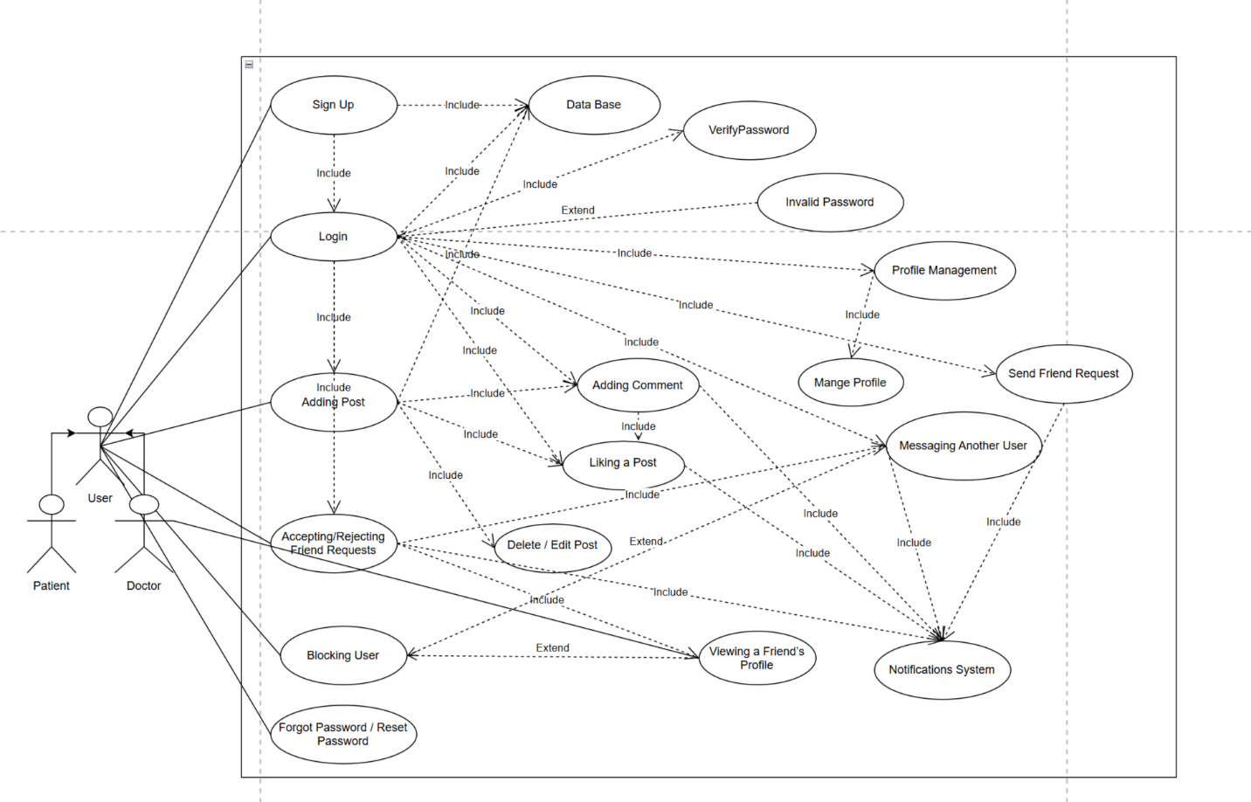

**2) ERD Diagram: -**

**3) Class Diagram: -**

